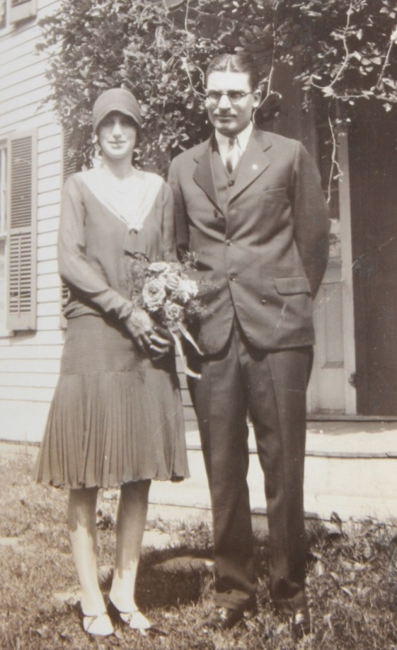

**Russell F. & Mary Helen Foster Wolfe - 15 Jun 1929**



Lois Ann Wolfe, daughter of Mary and Russell Wolfe – 1933